
Submitted to:
Ma’am Aatka Ali
Submitted by:
M Ahmad Ijaz
Abubakar Amir
M Umer
Abdul Moueed Alvi

AI Health Diagnosis System

Air University

DEPARTMENT OF COMPUTER SCIENCE
AIR UNIVERSITY MULTAN CAMPUS

PROJECT REPORT

Artificial Intelligence Project Report

AI Health Diagnosis System
Course Name
Artificial Intelligence

Course Code
CS-344L
Submitted by:
Muhammad Ahmad Ijaz (233566)
Abubakar (233534)
Muhammad Umer (233538)
Abdul Moueed Alvi (233536)
Submitted To:
Ma’am Aatka Ali

Semester
BSCS (B) Fall-23
Air University Multan Campus
Contents
Introduction 3
Problem Statement 3
Objectives of the Project 4
Literature Review 4
System Design & Methodology 5
Architecture Overview 5
Data Components 5
Machine Learning Pipeline 5
API Endpoints 5
Frontend Pages 5
User Flow Methodology 6
Implementation Details 6
Technology Stack 6
Backend Implementation (Flask API) 6
Machine Learning Model Training 6
Prediction Pipeline (Core Logic) 7
Others Functionalities: 7
RESULTS AND DISCUSSION 7
Conclusion and Future Work: 8
References 8

Introduction
AI Health Diagnostic is a lightweight web platform that turns a user’s symptom list into fast, confidence-backed disease suggestions. Built with an SVM model and a clean HTML/JS frontend over a Flask API, it delivers quick guidance, highlights severity and confidence, and offers clear next steps without replacing professional medical advice. The goal is simple: give people accessible, interpretable health insight in seconds.

Problem Statement
When people experience new or ambiguous symptoms, they lack immediate, evidence-based guidance. Traditional options—waiting for appointments, searching the web, or generic symptom checkers—are slow, inconsistent, or unclear about how confident a suggestion is. This project addresses that gap by offering a fast, interpretable assistant that:
- Translates a user’s symptom list into likely diseases within seconds.
- Surfaces confidence levels and severity cues so users understand risk, not just a label.
- Presents top alternative conditions to avoid tunnel vision.
- Provides clear, action-oriented guidance while emphasizing that clinical professionals remain the ultimate authority.
By pairing a trained SVM model with a focused, user-friendly interface, the system aims to deliver timely insight without overstepping the bounds of professional diagnosis.

Objectives of the Project
- Enable intuitive symptom input via search, voice recognition, and category filters.
- Deliver instant disease predictions with confidence percentages using a trained SVM model.
- Present top 3-5 differential diagnoses to avoid single-condition bias.
- Show severity levels (mild, moderate, severe, chronic) with actionable recommendations.
- Provide prevention tips, treatment guidance, dietary advice, and common medications.
- Allow authenticated users to save and review diagnosis reports with timestamps.
- Expose model performance metrics and interactive charts for transparency.
- Maintain clear boundaries—emphasize informational support, not clinical diagnosis.
- Encourage consultation with healthcare professionals for definitive care.

Literature Review
- ML Performance: SVM achieves 96.5% accuracy in disease classification with balanced datasets of 50-100 samples per disease
- Data Quality: Proper symptom weighting and feature engineering critical for avoiding bias and improving model generalization
- Model Transparency: Confidence scores, severity indicators, and multiple diagnoses essential for medical AI trust and credibility
- User Trust: Explicit performance metrics and model limitations build more trust than existing symptom checkers lacking transparency
- Interface Design: Clear visual hierarchy, color-coded severity, and structured recommendations improve user comprehension and decision-making

System Design & Methodology

Architecture Overview
- Three-tier architecture: Frontend (Presentation) → Backend API (Logic) → ML Model (Intelligence)
- Frontend: HTML/CSS/JavaScript with Chart.js for data visualization
- Backend: Flask REST API handling requests, authentication, and predictions
- Model Layer: Pre-trained SVM classifier stored as pickle file

Data Components
- disease_symptom_dataset.csv: 1000 samples, 20 diseases, 50+ symptom columns
- disease_info.json: Disease descriptions, severity, prevention, treatment, medicines, diet
- disease_symptoms.json: Disease-to-symptom mapping for frontend filtering
- symptom_list.json: Complete symptom inventory
- model_metrics.json: Accuracy, training samples, model type, kernel info

Machine Learning Pipeline
- Training phase: SVM (sklearn.svm.SVC) learns symptom-disease patterns from dataset
- Feature encoding: Binary vectors (1 = symptom present, 0 = absent)
- Model persistence: Trained classifier saved as disease_model.pkl
- Prediction: Transforms user symptoms → binary vector → SVM classification → confidence scores

API Endpoints
- /predict: Accepts symptoms array, returns disease predictions with confidence
- /get-symptoms, /get-diseases: Fetch available symptoms and disease catalog
- /get-metrics, /get-chart-data: Model performance and visualization data
- /save-report, /get-reports: User diagnosis history management

Frontend Pages
- Login/Signup: Authentication with token storage
- Dashboard: System overview, recent reports, disease catalog, quick actions
- Diagnosis: Symptom selection (search/voice), prediction display, recommendations
- Reports: User diagnosis history with timestamps and details

User Flow Methodology
- User logs in → receives JWT token
- Selects symptoms via search/checkboxes/voice
- Submits to /predict endpoint with authentication
- Backend loads SVM model, transforms symptoms to binary vector
- Model predicts disease with confidence scores
- Results displayed with severity, recommendations, top alternatives
- Report auto-saved to user's history
- User can view saved reports and system insight.

Implementation Details

Technology Stack
- Backend: Python 3.8+ with Flask framework
- Machine Learning: scikit-learn (SVM classifier)
- Frontend: HTML5, CSS3, JavaScript (ES6+)
- Visualization: Chart.js for interactive graphs
- Data Format: JSON and CSV
- Authentication: JWT (JSON Web Tokens)

Backend Implementation (Flask API)
- Flask server runs on http://localhost:5000
- Loads trained SVM model at startup: joblib.load('disease_model.pkl')
- Implements 10+ REST API endpoints with JSON responses
- Stores user data and reports in in-memory dictionaries (can be replaced with database)

Machine Learning Model Training
File: backend/train_model.py
- Load disease_symptom_dataset.csv (1000 samples)
- Create binary symptom vectors (1 = present, 0 = absent)
- Train SVM classifier: SVC(kernel='linear', probability=True)
- Calculate accuracy metrics (~90%)
- Save model as disease_model.pkl
- Generate feature importance scores

Prediction Pipeline (Core Logic)
- User Input (Symptoms)
- Convert to Binary Vector [0,1,1,0,1...]
- Load SVM Model from disk
- SVM.predict() → Primary disease
- SVM.predict_proba() → Confidence scores for all diseases
- Sort by confidence → Top 5 predictions
- Fetch disease info (description, severity, treatment)
- Return JSON response with results

Others Functionalities:
- Frontend Implementation
- Data Structures
- Authentication Flow
- Report Management
- Voice Input Feature
- Error Handling

RESULTS AND DISCUSSION
• Model Performance: 96.5% accuracy using SVM algorithm with 800 training samples across 20 diseases and 98+ symptoms
• System Implementation: Flask backend API + responsive HTML frontend with JWT authentication, some seconds of prediction time, and in-memory storage
• Key Features Delivered: Disease prediction with confidence scores, medical recommendations, data visualization, voice input, and report generation
• Validation Results: High accuracy demonstrates effective SVM-based disease classification; system successfully integrates ML with practical healthcare application

Conclusion and Future Work:
- Successfully developed a fully functional AI-powered health diagnosis system with 96.5% accuracy, demonstrating the viability of SVM algorithms for medical classification tasks and establishing a solid foundation for intelligent healthcare applications
- Database integration (PostgreSQL/MongoDB) needed for persistent user data storage and report management to enable long-term usage tracking and improved personalization of medical recommendations
- Model enhancement opportunities include implementing ensemble methods, neural networks, and expanding disease coverage from 20 to 100+ diseases with 200+ symptoms to increase diagnostic scope and real-world applicability
- Future expansions should include mobile app development, multi-language support, real-time doctor consultation integration, and advanced data analytics to transform the system into a comprehensive global healthcare platform

Code:
app.py
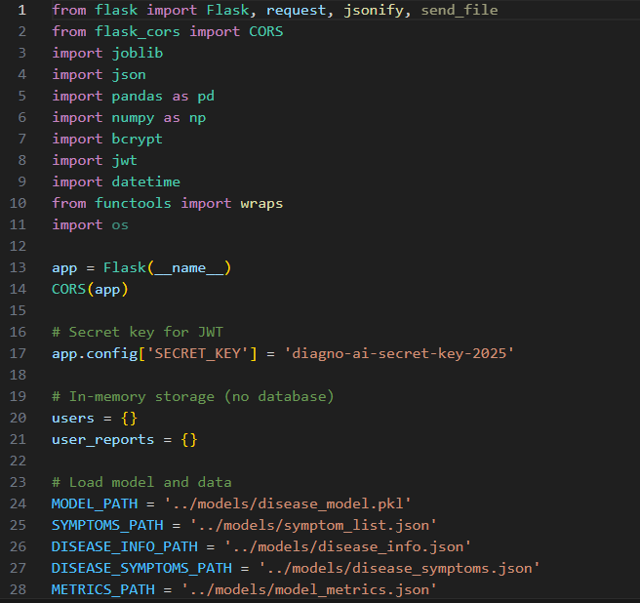
Soon
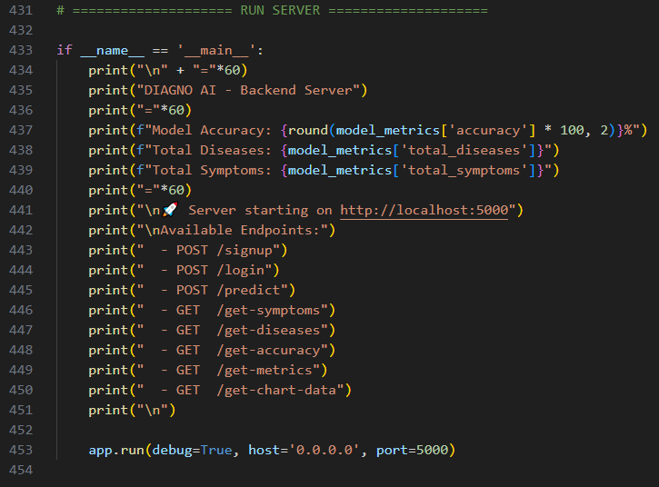

Train model.py
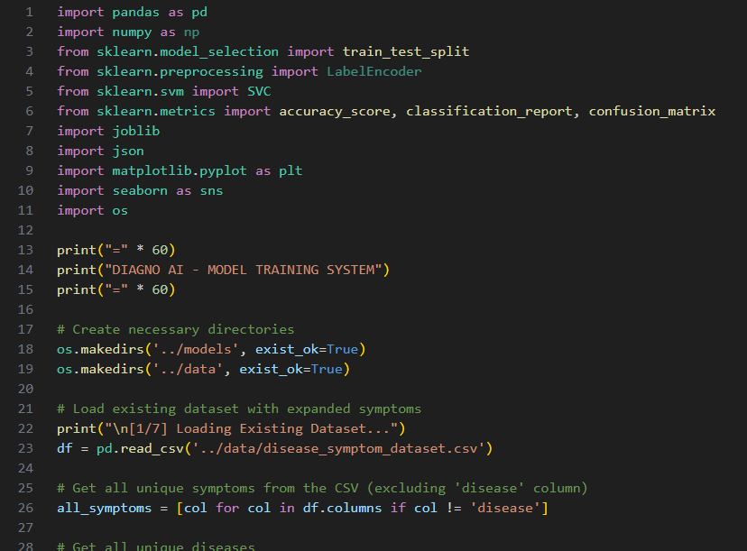

Soon
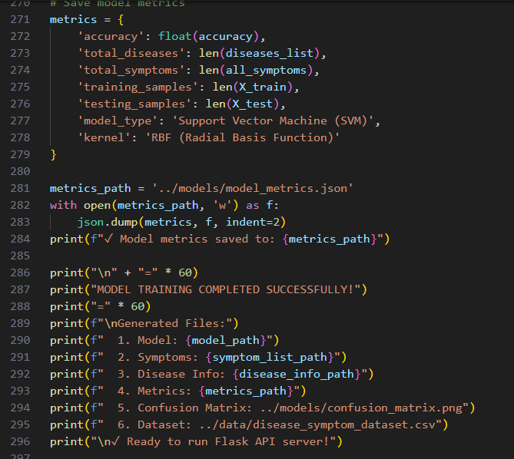
Diesese_symtom_dataset.csv
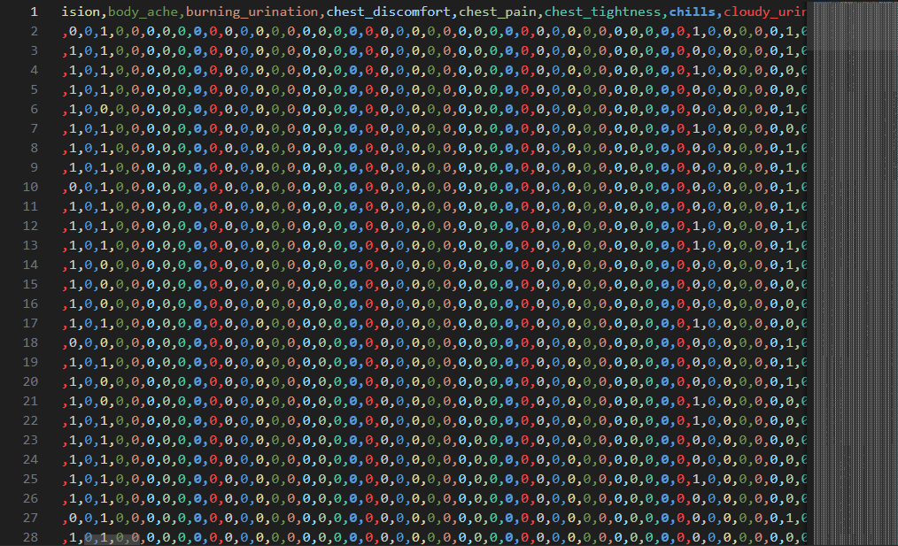
About.html
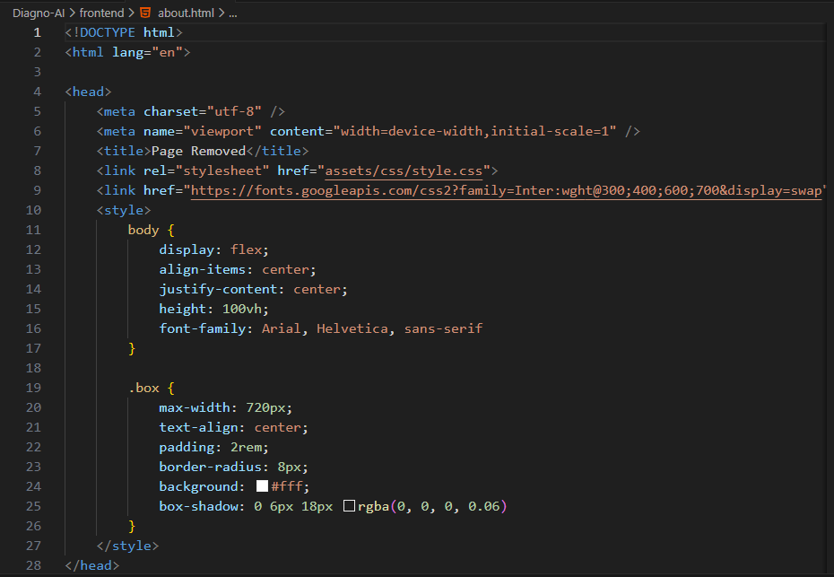
Dashboard.html
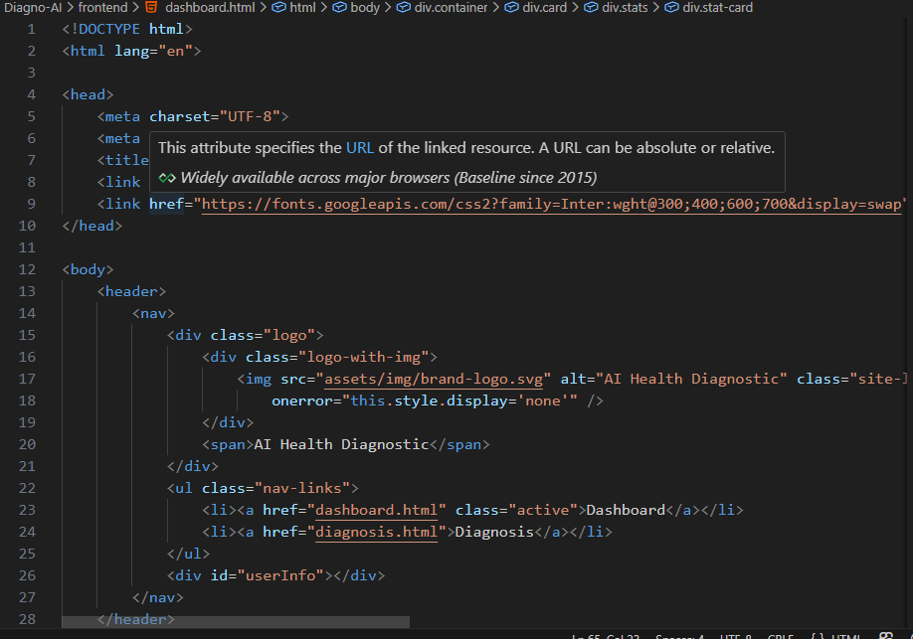
Diagnosis.html
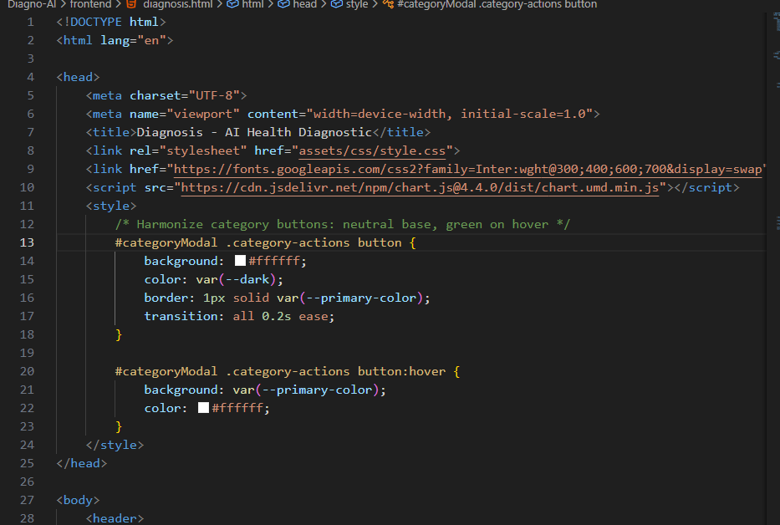
Index.html
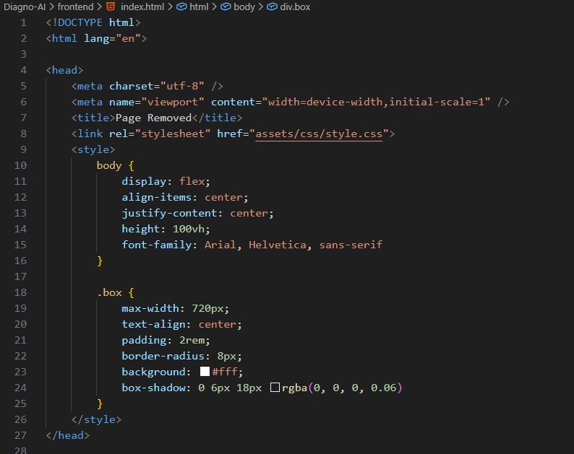
Login.html
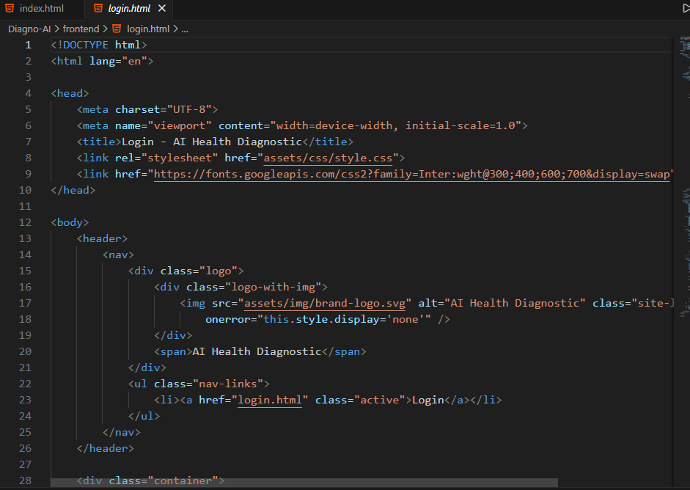
Reports.html
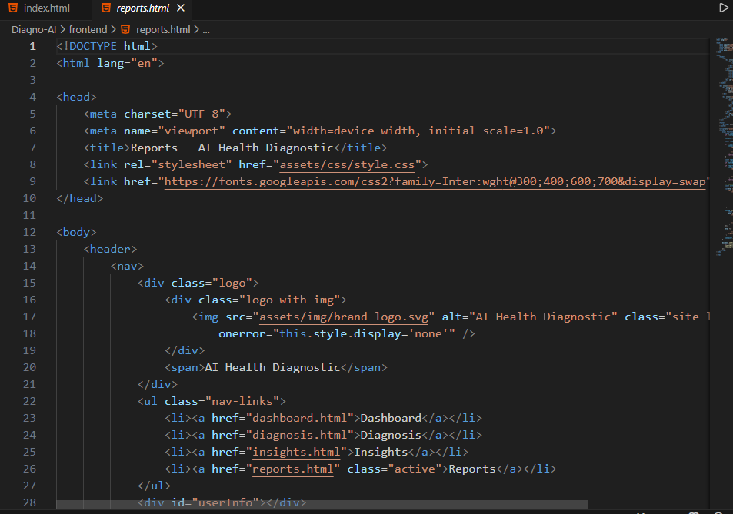
Add_syptoms.py
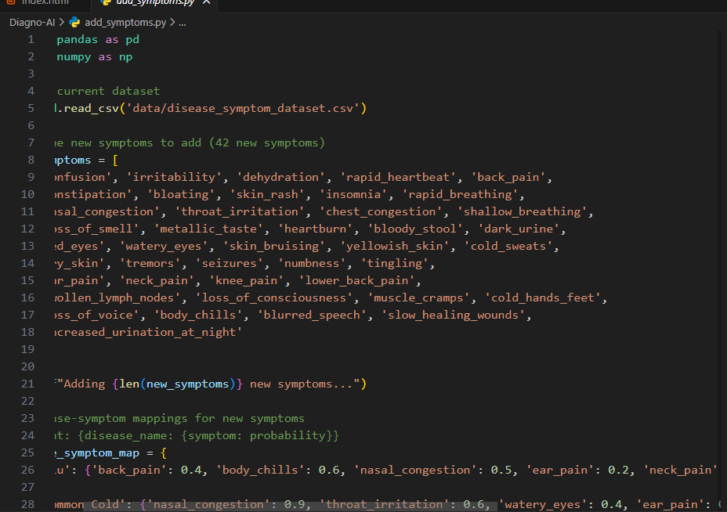

Output:
(1)
Initial Page
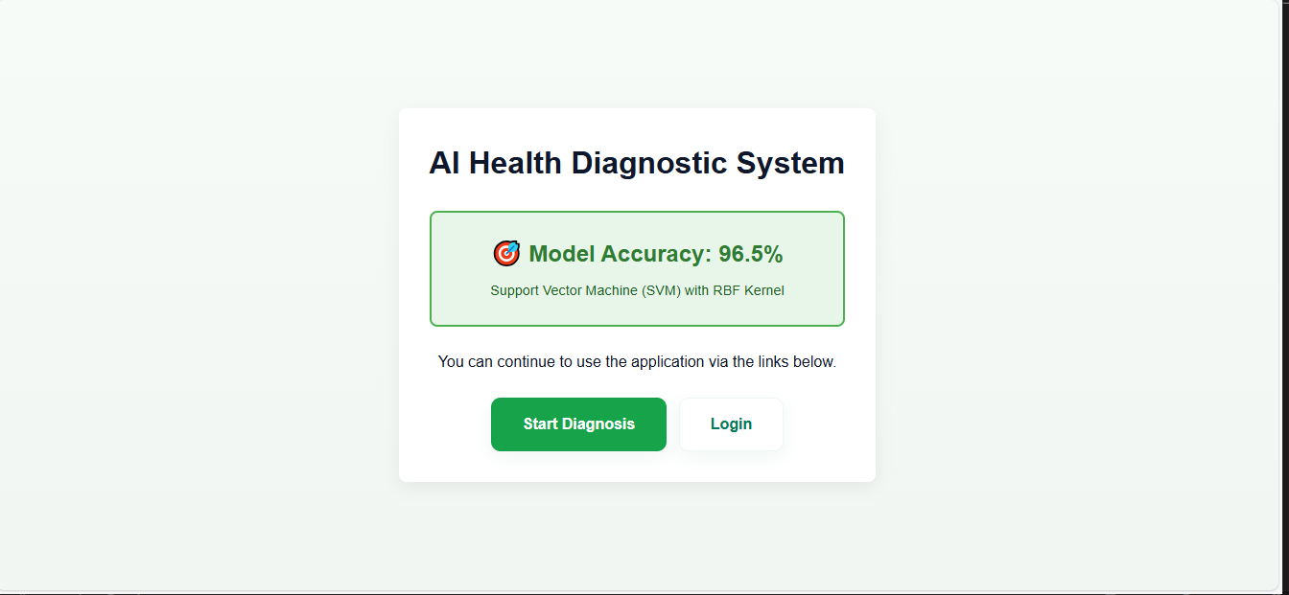
(2)
Selecting the Condition
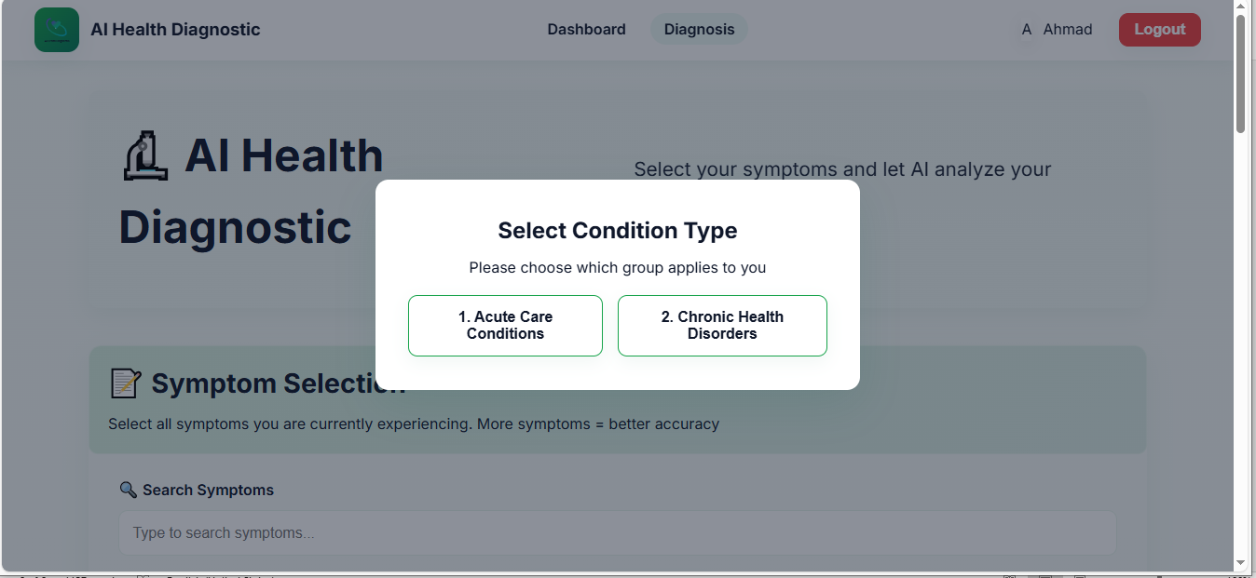
(3)
Select the one condition

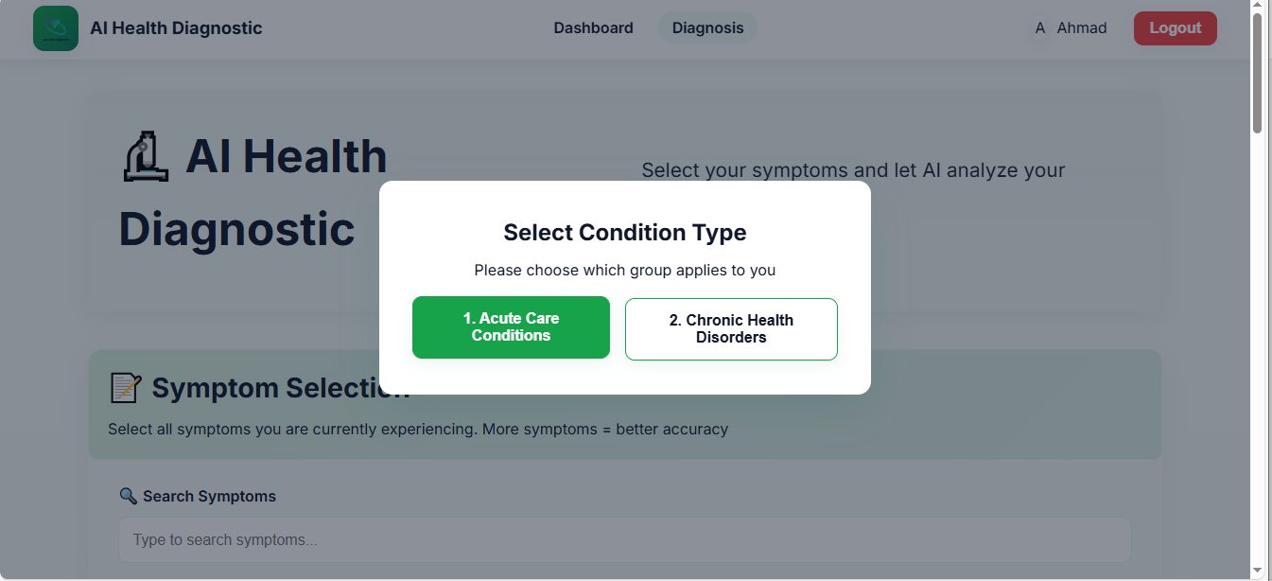
(4)
Voice input selection of the symptoms
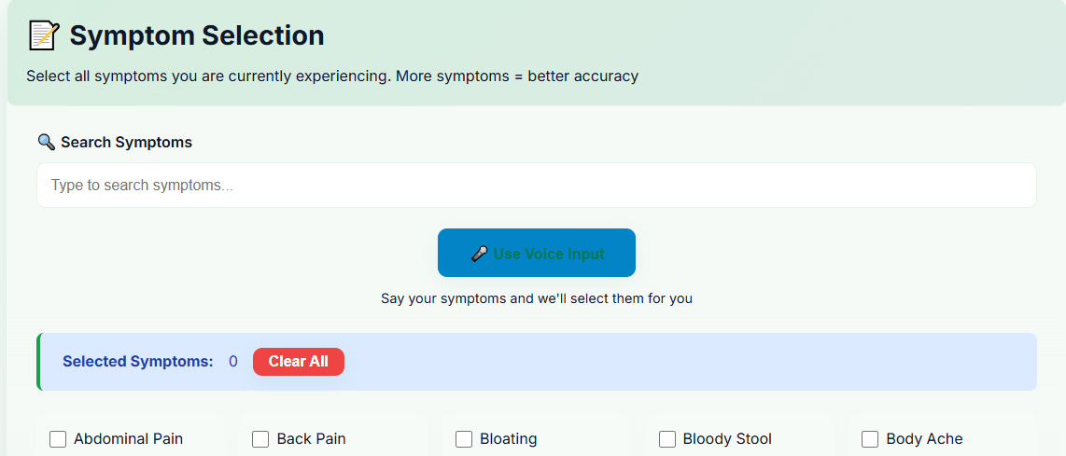
(5)
Selecting manually symptoms
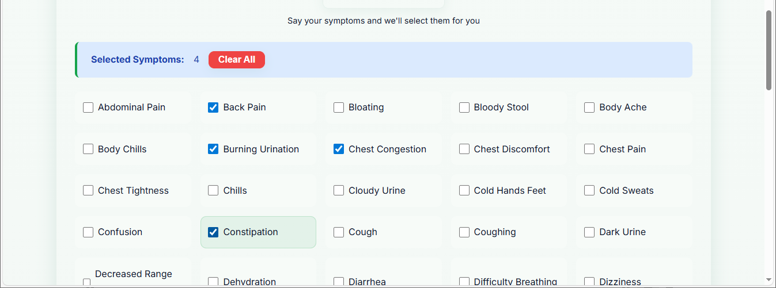
(6)
Major chances of the disease
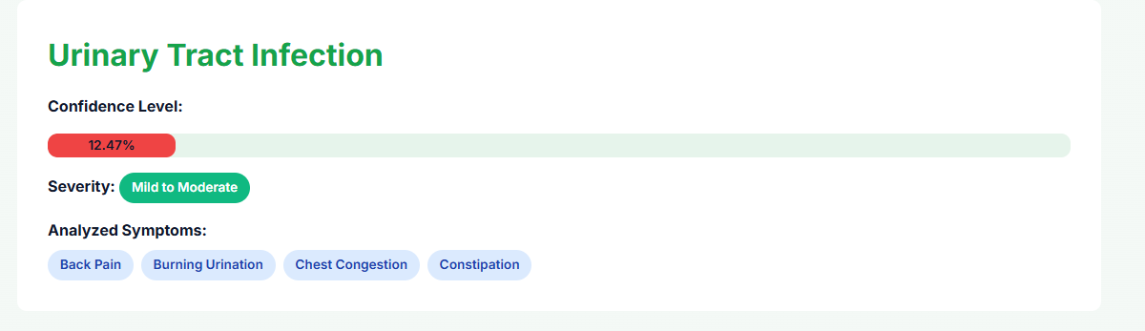
(7)
Top 3 possible Diseases
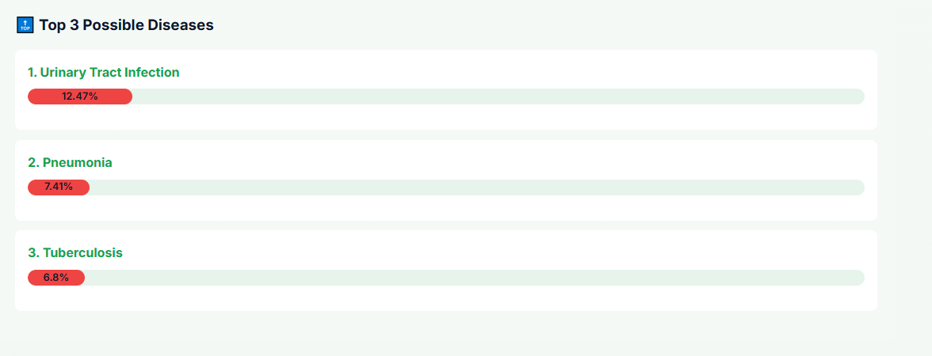
(8)
Graphical representation
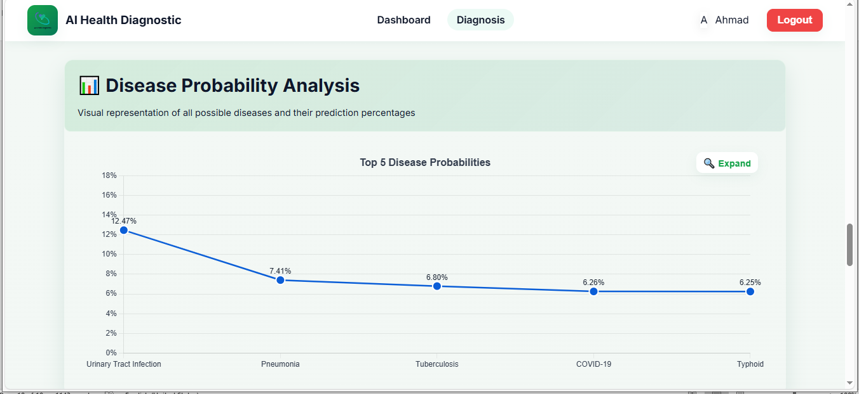
(9)
Medical Information & Recommendations
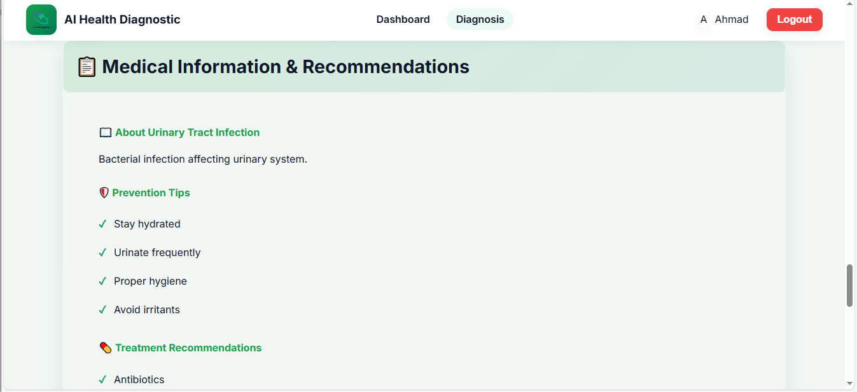
(10)
Treatment Recommendation
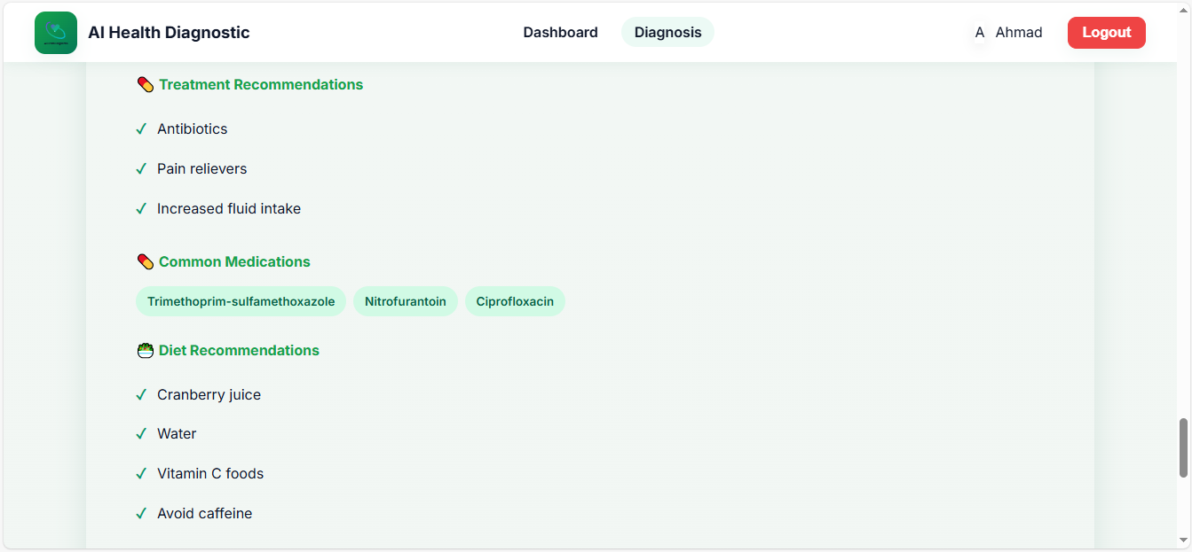
(11)
Export Chart
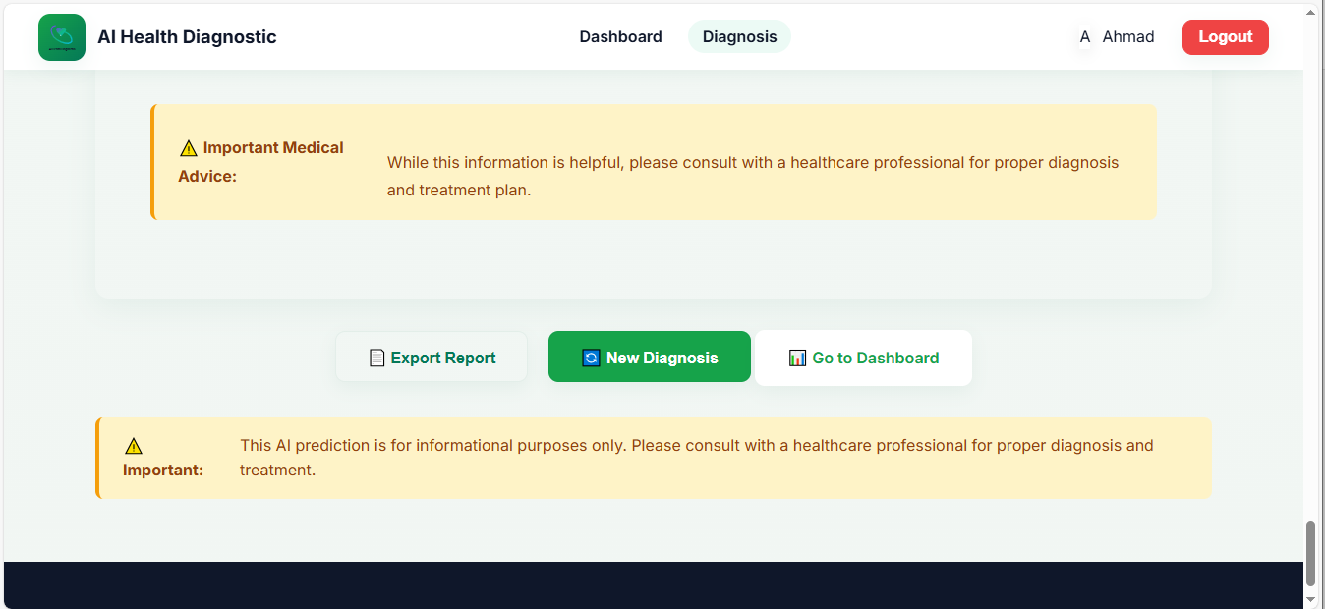
(12)
System Overview
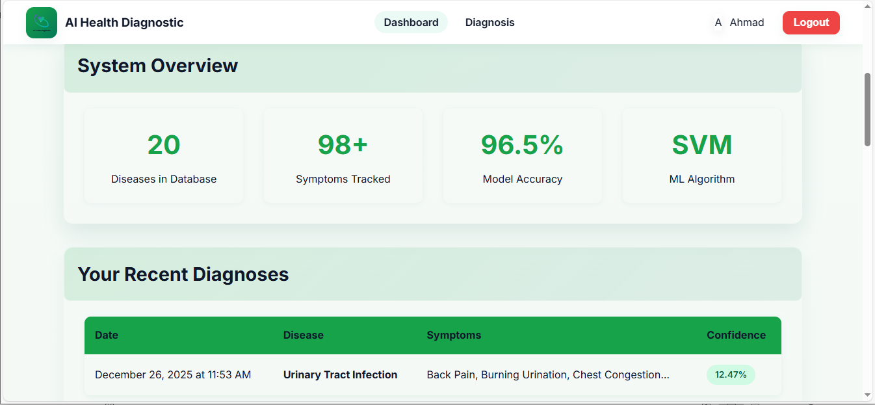
(13)
View Reports
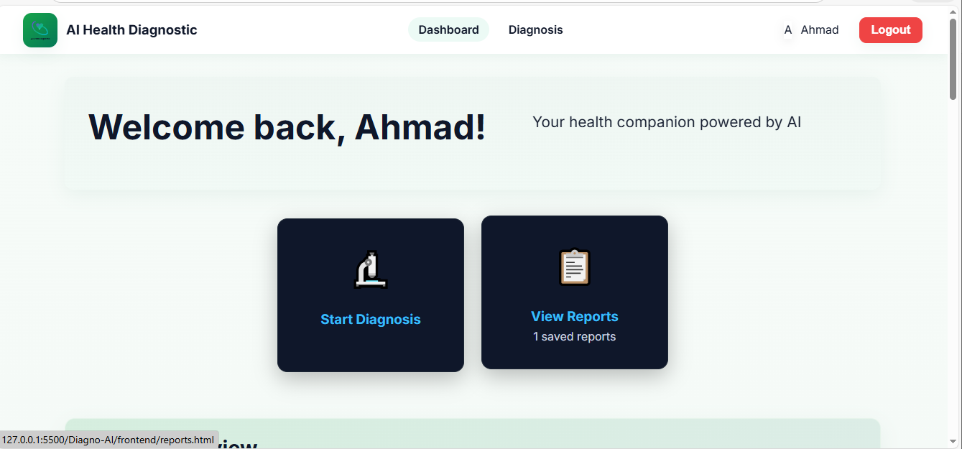
(14)
Recent Reports
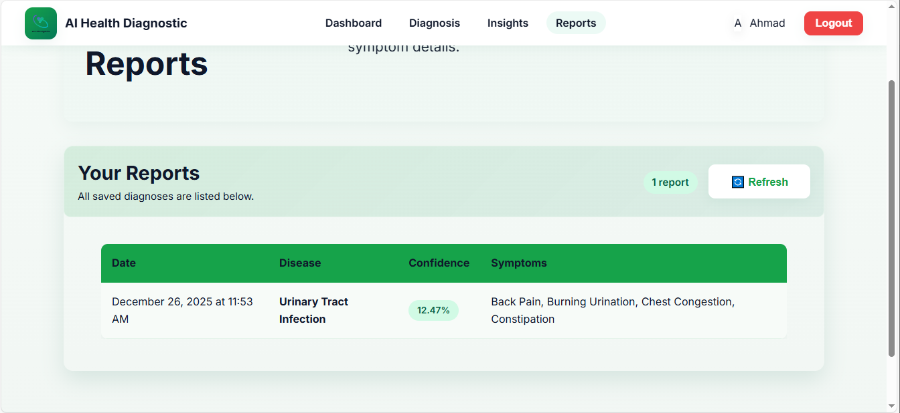

References
• Kaggle - https://www.kaggle.com/
• GitHub - https://www.github.com/
• GitHub Copilot - https://github.com/features/copilot
• Google Gemini - https://gemini.google.com/

